**Insurance Renewal System**

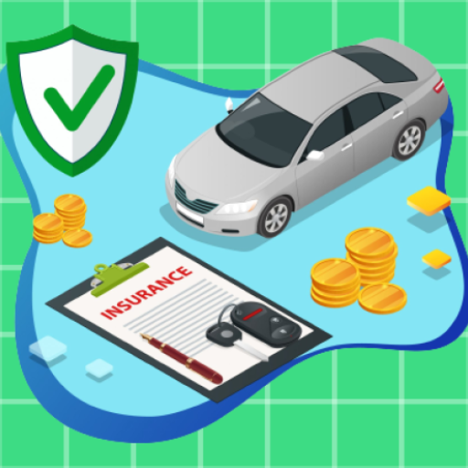

**E-Project**

**Group Members**

|  |  |
| --- | --- |
| Student Name | Enrollment No |
| Mr.Hamza Haroon | Student1276643 |
| Mr. Hassan Mujtaba | Student1311640 |
| Mr. Muhammad Wahaj | Student1312214 |
| Mr. Furqan-Ur-Rehman | Student1311432 |
| Mr. Farzam Ahmed | Student1312165 |

**Faculty: Miss. Tooba Khawar**

**Batch Co-Coordinator: Miss Ariba Ali**

**Batch: 2104B1**

**Curriculum: OV-ACCP-PRIME (6740)**

**User Guide**

**Splash Screen /Activity**

* When Users open the app by clicking on the app icon, this below page will be appeared on the screen for just few second.

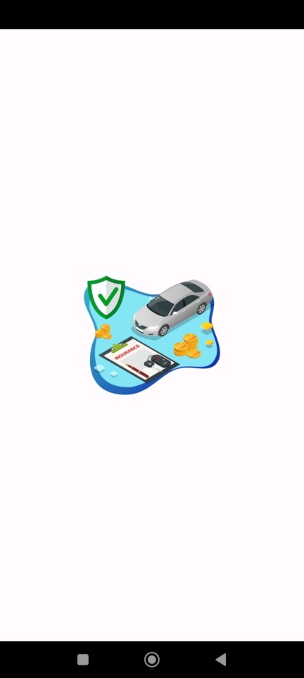

**Main Activity/Home Page**

* After disappearing Splash Screen, Users can view this Main activity Page or Screen.
* Where User(s) can check the insurance after buying /renewal of Insurance.
* After Renewal of Insurance, user(s) can enter your insurance Policy number (in this case his or her car no. is his or her insurance policy number from which their car registered) for check the policy whether it is renewed or not.

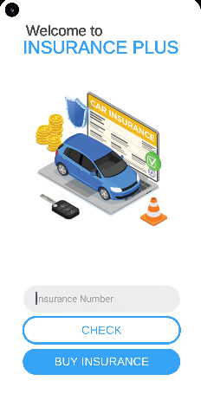

**Buy Insurance Activity/ Page**

* When User(s) click on the Buy Insurance button which is shown in Main Activity Page, this below page or screen will be appeared.
* Where User(s) can view the Personal Details, vehicle Details and Insurance Plan.
* User(s) can fill the details one by one for renew the policy as per the mentioned Policy plan.

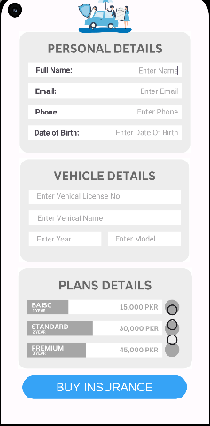

**Payment Details Activity/ Page**

* When User(s) click on the Buy Insurance button after filling all the information as we discussed on previous page, this below screen would be appeared for getting Payment Details.
* Where User(s) can insert the details of his / her credit card for confirmed payment or renewed insurance.

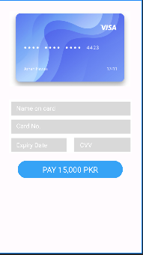

**View Details Activity/ Page**

* When User(s) click on the Pay Button which is mentioned above, his or her payment would be confirmed.
* After Confirmation, user(s) can visit the Main activity page or screen where he or she can view the check insurance, whether his or her insurance will be renewed or not.
* In order to check the renewed insurance, he or she insert his or her policy number in the given block, and then click on check button, if the data is visible in the form of view, his or her insurance have been renewed, as given in the right side of the main activity.

 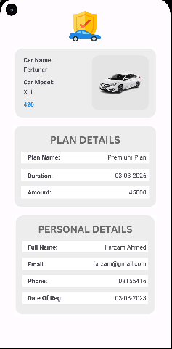

**Main Activity and View Page**